Erasyl Umirbay 2439- SE  
Assignment #1: HTML Basics (Page Structure)  
  
Step 0–1: Basic Structure & About Me

I created the file index.html and added the basic HTML boilerplate. Then I included my name, course, and an About Me section.

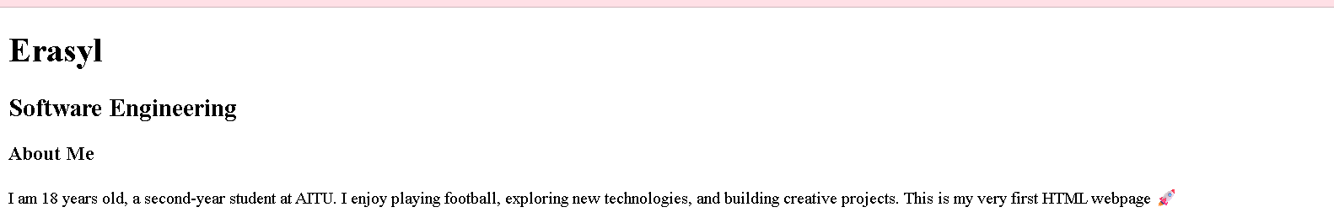  
Step 2: Lists

I added an ordered list of my hobbies and an unordered list of my favorite websites

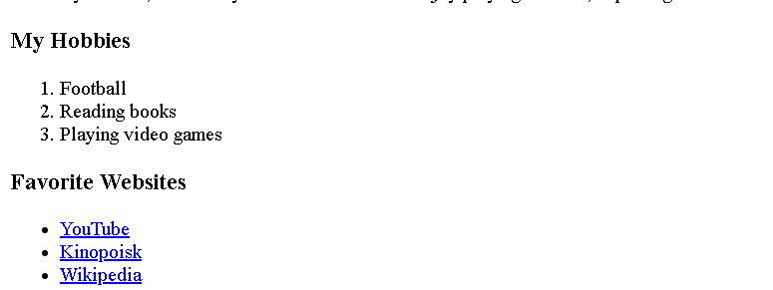  
Step 3: Images and Links

I inserted my photo using the <img> tag and added two useful links (Gmail and AITU website).

  
Step 4: Button

I created a simple button with the text 'Click Me'.

  
Step 5: Table (Schedule)

I created a table with three columns (Subject, Day, Time) and filled it with my weekly class schedule.

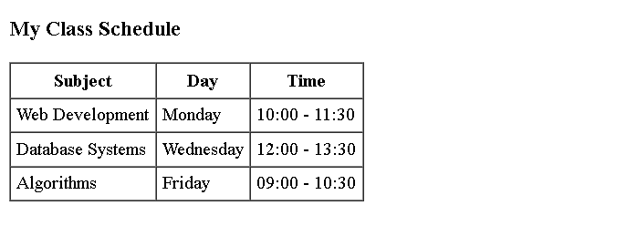  
Step 6: Page Layout (Optional)

I used a table to create a two-column layout: navigation on the left, content on the right. This makes my page more unique and structured.

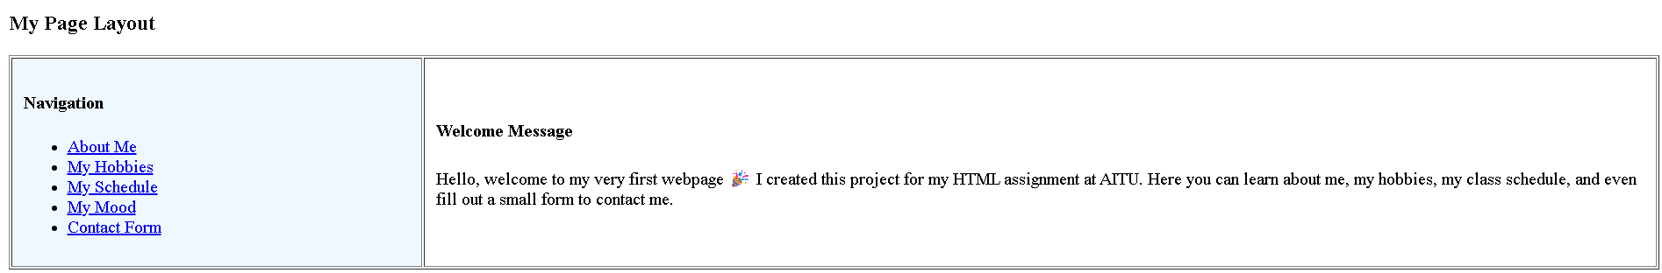  
Step 7: Emojis

I wrote a short paragraph about my mood and added at least three emojis to make it more expressive.

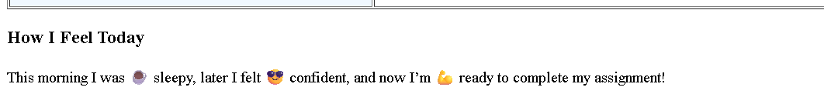  
Step 8: Form

I created a form with input fields for name, email, favorite color, and hobby, along with a submit button.

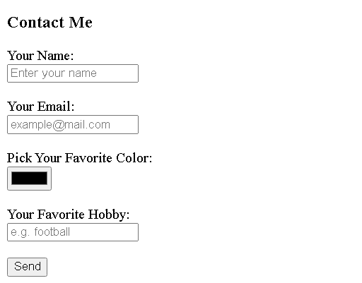  
Step 9: Publishing

I published my project using GitHub Pages. The final website is available at: https://erasyl228-code.github.io/AS1/

Summary

This assignment helped me understand the basics of HTML and how to structure a webpage. I also learned how to publish my work online using GitHub Pages.